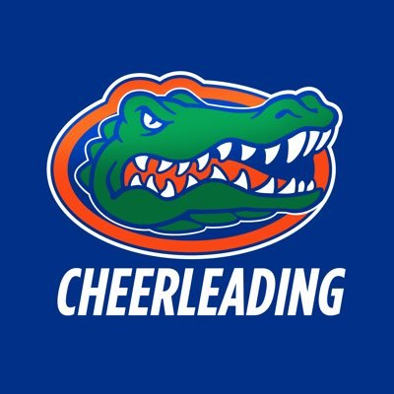**MJHS CHEER**

CONGRATULATIONS TO THE FOLLOWING  
MEMBERS OF THE 2023-24 SQUAD:

# 1

# 2

# 3

# 4

Be on the lookout for a follow up email from the coaches Ms. Stephanie Grimes and Ms. Tawny Nash for information regarding upcoming meetings, fittings, and payments! Great job ladies!!